Top 10 Strategic Technology Trends for 2019

**Published:** 15 October 2018 **ID:** G00374252

**Analyst(s):** David Cearley, Brian Burke

Strategic technology trends have the potential to drive significant disruption and deliver significant opportunity. Enterprise architecture and technology innovation leaders must evaluate these top trends to identify opportunities, counter threats and create competitive advantage.

Key Findings

* Artificial intelligence (AI) opens up a new frontier for digital business. This is because virtually every application, service and Internet of Things (IoT) object incorporates an intelligent aspect to automate or augment application processes or human activities.
* The way we perceive and interact with technology is undergoing a radical transformation. Conversational platforms, augmented reality, virtual reality and mixed reality will provide more natural and immersive ambient experience within the digital world.
* Digital representations of things and organizational processes are increasingly used to monitor, analyze and control real-world environments. These digital twins combined with AI and immersive experiences set the stage for open, connected and coordinated smart spaces.
* Formal mechanisms to identify technology trends and prioritize those with the biggest potential impact on the business create competitive advantage.

Recommendations

Enterprise architecture (EA) and technology innovation leaders driving business transformation through technology innovation must:

* Explore ways that essentially any physical device within the organization or the customer’s environment can be powered by AI-driven autonomous capabilities.
* Educate, engage and ideate with senior business leaders about their strategically relevant priorities and where AI can automate or augment human activities.
* Develop and deploy a mix of platforms that incorporate conversational interactions with virtual, augmented and mixed reality for targeted use cases to create an immersive user experience.
* Support IoT initiatives by developing and prioritizing targeted, high-value business cases to build digital twins of physical things and organizational processes.
* Learn about and monitor quantum computing while it is still in the emerging state. Identify real- world problems where it has potential and assess its possible impact on security.

Table of Contents

Strategic Planning Assumptions. 3

Analysis. 4

Trend No. 1: Autonomous Things. 6

Autonomous Physical Things and Autonomous Virtual Things. 7

A Range of Autonomous Capabilities. 8

Autonomous, Intelligent and Coordinated. 9

Trend No. 2: Augmented Analytics. 10

Empowering the Citizen Data Scientist. 11

Beyond the Citizen Data Scientist. 12

Take Action. 12

Trend No. 3: AI-Driven Development. 13

The Augmented Developer. 14

The Automated Developer. 15

Trend No. 4: Digital Twins. 16

Digital Twin of an Organization. 18

Trend No. 5: Empowered Edge. 20

Edge Computing and Cloud Computing Are Complementary Concepts. 20

Exploiting Advanced Capabilities at the Edge. 21

Communicating to the Edge — The Role of 5G. 22

Trend No. 6: Immersive Experience. 23

How We Perceive the Digital World Is Changing. 23

VR and AR Can Help Increase Productivity. 24

How We Interact With the Digital World Is Changing. 24

The Future Will Be an Ambient Experience. 25

Trend No. 7: Blockchain. 27

Trend No. 8: Smart Spaces. 30

Smart City Spaces Lead the Way. 33

Smart Spaces Are a Journey, Not a Destination. 33

Trend No. 9: Digital Ethics and Privacy. 34

Trend No. 10: Quantum Computing. 37

Quantum Computing and Security. 38

Quantum Computer Maturity. 39

Don’t Ignore QC, but Proceed With Caution. 40

Gartner Recommended Reading. 41

List of Figures

Figure 1. Top 10 Strategic Technology Trends for 2019. 6

Figure 2. A Framework for Assessing Autonomous Things. 7

Figure 3. The Evolution of Augmented Analytics. 11

Figure 4. Applying AI to the Development Process. 14

Figure 5. Digital Twins Are Digital Representations of Real-World Objects. 17

Figure 6. Cloud and Edge Computing Are Complementary Concepts. 21

Figure 7. The Future of the User Experience. 27

Figure 8. Key Elements of Blockchain. 28

Figure 9. Smart Space Evolution. 31

Figure 10. The Hierarchy of Intent. 35

Figure 11. Quantum Computing Timeline. 40

# Strategic Planning Assumptions

By 2021, 10% of new vehicles will have autonomous driving capabilities, compared with less than 1% in 2018.

Through 2020, the number of citizen data scientists will grow five times faster than the number of expert data scientists.

By 2022, at least 40% of new application development projects will have artificial intelligence co- developers on the team.

By 2021, half of large industrial companies will use digital twins, resulting in a 10% improvement in effectiveness for those organizations.

Through 2028, storage, computing, and advanced AI and analytics technologies will expand the capabilities of edge devices.

By 2022, 70% of enterprises will be experimenting with immersive technologies for consumer and enterprise use, and 25% will have deployed them to production.

By 2030, blockchain will create $3.1 trillion in business value.

By 2022, more than 50% of all people collaborating in Industry 4.0 ecosystems will use virtual assistants or intelligent agents to interact more naturally with their surroundings and with people.

By 2021, organizations that bypass privacy requirements and are caught lacking in privacy protection will pay 100% more in compliance cost than competitors that adhere to best practices.

By 2023, 20% of organizations will be budgeting for quantum computing projects, compared to less than 1% in 2018.

# Analysis

Digital transformation drives organizations to continually refresh their business models, and much of the change will be technology-enabled. Technology is also amplifying continuous change at an ever- increasing velocity. Technology innovation leaders must adopt a mindset and new practices that accept and embrace perpetual change. “Continuous next” is the strategy for achieving success in a world that is constantly changing. It positions organizations to foster perpetual innovation, integration and delivery. The top 10 strategic technology trends are a critical ingredient in driving a continuous innovation process as part of a continuous next strategy.

The future will be characterized by smart devices delivering increasingly insightful digital services everywhere. We call this the “intelligent digital mesh.” The intelligent digital mesh has been a consistent theme of Gartner’s strategic technology trends for the past two years, and it continues as a major driver through 2019. EA or technology innovation leaders seeking to exploit the intelligent digital mesh must respond to the disruptive technology trends driving this future.

There are three core themes to the intelligent digital mesh:

* The **intelligent** theme explores how AI — with a particular emphasis on machine learning — is seeping into virtually every existing technology and creating entirely new technology categories. The exploitation of AI will be a major battleground for technology providers through 2022. Using AI for well-scoped and targeted purposes delivers more flexible, insightful and increasingly autonomous systems.
* The **digital** theme focuses on blending the digital and physical worlds to create a natural and immersive digitally enhanced experience. As the amount of data that things produce increases exponentially, compute power shifts to the edge to process stream data and send summary data to central systems. Digital trends, along with opportunities enabled by AI, are driving the next generation of digital business and the creation of digital business ecosystems.
* The **mesh** theme refers to exploiting connections between an expanding set of people and businesses — as well as devices, content and services — to deliver digital business outcomes. The mesh demands new capabilities that reduce friction, provide in-depth security and respond to events across these connections.

Trends under each of the three themes continue to evolve, but more importantly the individual trends and related technologies are combining to begin realizing the overall vision embodied in the intelligent digital mesh. For example, AI in the form of automated things and augmented intelligence is being used together with the IoT, edge computing and digital twins to deliver highly integrated smart city spaces. The combined effect of multiple trends coalescing to produce new opportunities and drive new disruption is a hallmark of our top 10 strategic technology trends for 2019.

In addition to individual trends under each of the core themes, there are two broad trends on our 2019 list that span all three themes:

* **Digital ethics and privacy** are becoming critical elements of any technology decision. This trend is not simply about compliance. By 2021, organizations that bought compliance risk and are caught lacking in privacy protection will pay 100% more in compliance cost than competitors that adhere to best practices. Best practice means focusing not only on what you *have* to do but on what you *should* do ethically with regard to issues such as specific applications of AI or the creation of digital twins of people for marketing purposes.
* **Quantum computing (QC)** is an emerging trend with the potential for significant impact between 2023 and 2025. As such, we would not normally include it in our list of top 10 trends, which usually consists of trends that we expect will have a significant commercial impact within five years. However, recent advances, the potential disruption of QC, and the challenges of understanding it and applying it to business problems make it an important trend to add to an organization’s strategic roadmap. If QC reaches its potential, it will influence the evolution of many aspects of the intelligent digital mesh.

Our top 10 list (see Figure 1) highlights strategic trends that aren’t yet widely recognized but have broad industry impact and significant potential for disruption. Through 2023, technologies related to these trends will reach a level of maturity that crosses a critical tipping point; and they’ll experience significant changes. Examine the business impact of our top 10 strategic technology trends, and seize the opportunities to enhance your existing products, create new ones or adopt new business models. Prepare for the impact of digital business on your industry — it will transform the industry, and your business.

Figure 1. Top 10 Strategic Technology Trends for 2019

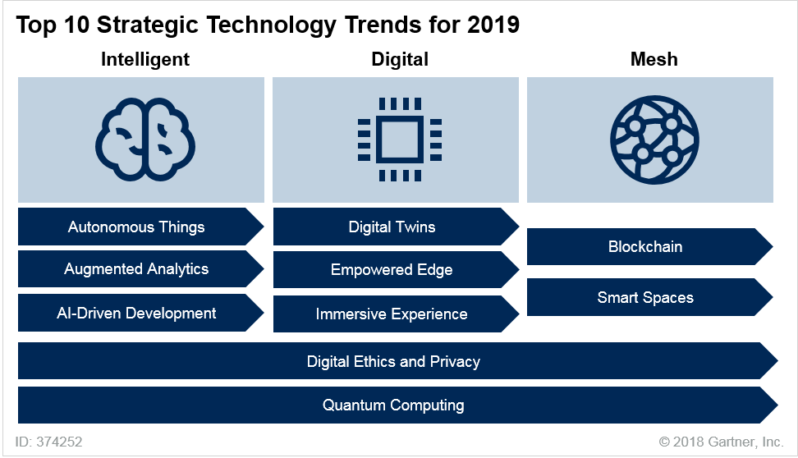

Source: Gartner (October 2018)

Trend No. 1: Autonomous Things

Autonomous things use AI to automate functions previously performed by humans. Their automation goes beyond the automation provided by rigid programing models, and they exploit AI to deliver advanced behaviors that interact more naturally with their surroundings and with people. Autonomous things come in many types, and operate across many environments with varying levels of capability, coordination and intelligence. Track the overall evolution of the technologies across the autonomous things framework (see Figure 2). Also, use this framework to consider the technical needs of particular use-case scenarios.

Figure 2. A Framework for Assessing Autonomous Things

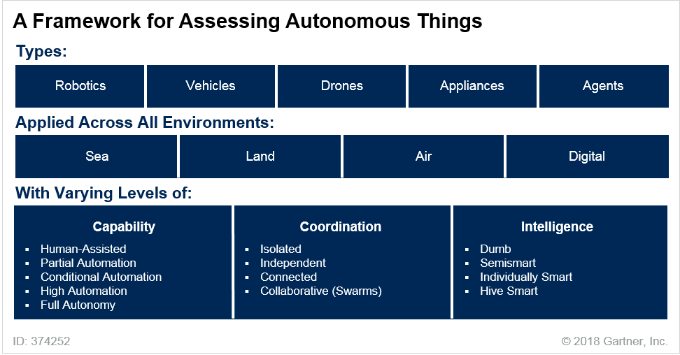

Source: Gartner (October 2018)

Autonomous Physical Things and Autonomous Virtual Things

Autonomous things are often in the form of a physical device operating in the real world. Examples include robots, drones and autonomous vehicles. AI-powered IoT elements, such as industrial equipment and consumer appliances, are also a type of autonomous thing. Autonomous things may operate on land, in the air or at sea, but each physical device has a focus for its operation as it relates to humans. For example:

* Robots operate independently of humans with a degree of mobility
* AI-powered IoT elements operate independently of humans, often with little or no mobility
* Drones are operated remotely by humans
* Autonomous vehicles may have human passengers or cargo

Explore ways that AI-driven autonomous capabilities can power virtually any physical device in the organization or the customer’s environment. Although autonomous things offer many exciting possibilities, they cannot match the human brain’s breadth of intelligence and dynamic general- purpose learning. Instead, they focus on well-scoped purposes, particularly for automating routine human activities. Create business scenarios and customer journey maps to identify and explore the opportunities that will deliver compelling business outcomes. Seek opportunities to incorporate the use of intelligent things in traditional manual and semiautomated tasks. Examples of business scenarios include:

* **Crime prevention through autonomous patrolling robots.** Microsoft, Uber and other technology giants are using Knightscope K5 robots to predict and prevent crime using autonomous robots, analytics and engagement.1
* **Advanced agriculture.** Projects such as the U.S. National Robotics Initiative are pushing agriculture automation to the next level.2 Examples include creating planning algorithms for robots to autonomously operate farms; having unmanned aerial vehicles (UAVs) operate with human scouts to study solutions for farmers of specialty crops; and vertical farming.
* **Safer automobile transportation.** High-technology firms (such as Alphabet, Tesla, Uber, Lyft and Apple), and traditional automotive companies (such as Mercedes-Benz, BMW, Nissan, Toyota and Ford), hope that, by removing the human-error element, self-driving cars will lower the number of automobile accidents. By 2021, 10% of new vehicles will have autonomous driving capability, compared with less than 1% in 2017.

Autonomous things include things that operate solely in the digital world without any physical manifestation. We predict that, as communications become multidimensional and multimodal, new forms of interactions, including virtual assistants and independent agents, will facilitate the exchange of information and data. The ability to use natural language processing for aligning communications across business units and locations will personalize and expand the collaboration. This will impact not only the traditional workplace environment, but also frontline workers and industrial environments. By 2022, more than 50% of all people collaborating in Industry 4.0 ecosystems will use virtual assistants or independent agents to interact more naturally with their surroundings and with people:

* **Virtual assistants** operate at the explicit or implicit direction of the user (for example, virtual personal assistants [VPAs] and chatbots), rather than completely autonomously from the user. They enable automation of routine tasks in the near term. More sophisticated tasks will be automated over time.
* **Independent agents** operate in the background and are not invoked directly by the user. For example, an independent agent might monitor the health of a system and proactively change software configurations.

A Range of Autonomous Capabilities

Autonomous things operate along a spectrum of autonomy, from semiautonomous to fully autonomous. The word “autonomous,” when used to describe autonomous things, is subject to interpretation. When Gartner uses this term to describe autonomous things, we mean that these things can operate unsupervised within a defined context or to complete a task. Autonomous things may have various levels of autonomy. For example, a self-directing vacuum cleaner may have limited autonomy and smartness, while a drone might autonomously dodge obstacles and fly into buildings through windows and doors.3

It’s expedient to use the levels of autonomy often applied to evaluating autonomous vehicles when considering use cases for robots, drones, AI-powered IoT devices and agents:

* Human-assisted
* Partial automation
* Conditional automation
* High automation
* Full automation

Autonomous, Intelligent and Coordinated

As autonomous things proliferate, we expect a shift from stand-alone intelligent things to a swarm of collaborative intelligent things. In this model, multiple devices will work together, either independently of people or with human input. For example, if a drone examined a large field and found that it was ready for harvesting, it could dispatch an “autonomous harvester.” In the delivery market, the most effective solution may be to use an autonomous vehicle to move packages to the target area. Robots and drones aboard the vehicle could then effect final delivery of the package. The military is leading the way in this area and is studying the use of drone swarms to attack or defend military targets.4 Other examples include:

* Intel’s use of a drone swarm for the opening ceremony of the Winter Olympic Games in 20185
* A plan for Dubai to use autonomous police vehicles that can deploy their own drones for surveillance6
* Cooperative merge scenarios by Honda and other car manufacturers, in which vehicles communicate with one another to optimize traffic flows7

Evaluate the potential use of collaborative autonomous things, not only in the context of autonomous physical things working together, but in the context of autonomous virtual things as well. This level of interaction is in its early stages, but the need to coordinate actions across a network of autonomous things will increase dramatically as the use of virtual assistants and independent agents grows. By 2021, swarm intelligence will be a core design element for at least 30% of organizations deploying AI-enhanced systems. Example use cases will include:

* Coordinated interaction among multiple virtual assistants across digital workplace tools and general-purpose environments (for example, mobility) to execute a complex user request that touches multiple systems
* Coordinated data handoff and actions among multiple levels of independent agents operating across automated processes in infrastructure management, applications and security to ensure smooth and secure IT operations

*Related Research:*

* “Hype Cycle for Connected Vehicles and Smart Mobility, 2018”
* “Use Scenarios to Plan for Autonomous Vehicle Adoption”
* “Hype Cycle for Drones and Mobile Robots, 2018”
* “Supply Chain Brief: Favorable Regulations Will Accelerate Global Adoption of Autonomous Trucking”
* “Toolkit: How to Select and Prioritize AI Use Cases Using Real Domain and Industry Examples”
* “Swarms Will Help CIOs Scale Up Management for Digital Business”

Trend No. 2: Augmented Analytics

Augmented analytics focuses on a specific area of augmented intelligence (see Note 1). Augmented analytics uses automated machine learning to transform how analytics content is developed, consumed and shared. It includes:

* Augmented data preparation, which uses machine learning automation to augment data profiling and data quality, harmonization, modeling, manipulation, enrichment, metadata development, and cataloging. This trend is also transforming all aspects of data management, including automating data integration and database and data lake administration.
* Augmented analytics as part of analytics and business intelligence (BI), which enables business users and citizen data scientists to automatically find, visualize and narrate relevant findings without building models or writing algorithms. These findings may include correlations, exceptions, clusters, segments, outliers and predictions. Users explore data via autogenerated visualizations and conversational interfaces, including natural language query and natural- language-generated narration of results.
* Augmented data science and machine learning, which uses AI to automate key aspects of data science and machine learning/AI modeling, such as feature engineering, model selection (automated machine learning [autoML]), model operationalization, explanation, tuning and management. This reduces the need for specialized skills to generate, operationalize and manage advanced analytic models.

Augmented analytics represents a third major wave for data and analytics platform capabilities (see Figure 3). Modern analytics and BI platforms have been transformative in the way they enable business users to generate analytics insights. Data science and machine learning platforms have also made it easier to build machine learning and AI models. However, many of the activities associated with preparing data, finding patterns in data, building machine learning models on large and complex data, and sharing and acting on insights remain highly intensive activities. Manually exploring every possible pattern combination and determining whether the findings are the most relevant, significant and actionable becomes impossible as the number of variables to analyze increases. Typically, users default to exploring their own biased hypotheses, missing key findings and drawing their own incorrect or incomplete conclusions. This may adversely affect decisions and outcomes. Augmented analytics enables the exploration of more hypotheses and the identification of hidden patterns. It also removes personal bias. However, care must be taken not to inadvertently introduce new biases in the AI algorithms themselves.8

Figure 3. The Evolution of Augmented Analytics

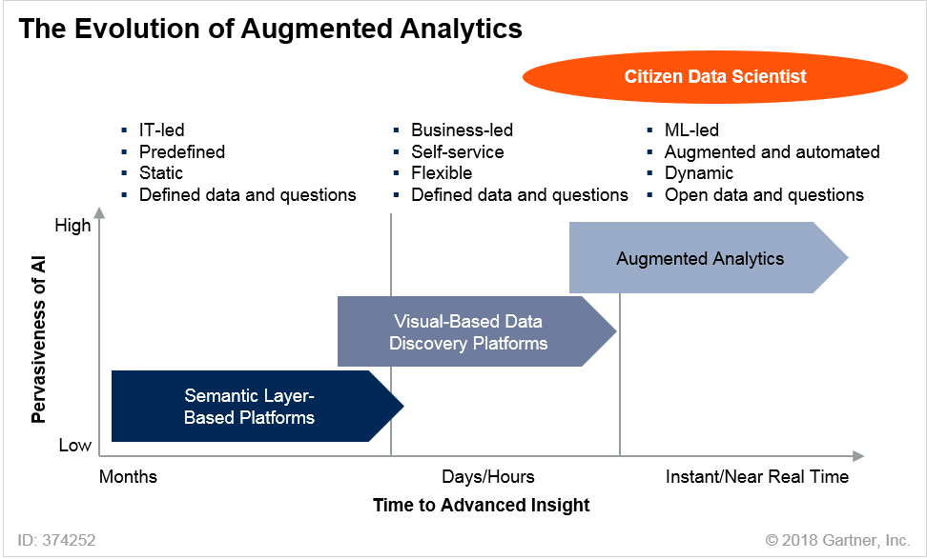

ML = machine learning

Source: Gartner (October 2018)

Augmented analytics capabilities will advance rapidly along the Hype Cycle to mainstream adoption, as a key feature of data preparation, data management, modern analytics, business process management, process mining and data science platforms. Automated insights from augmented analytics will also be embedded in enterprise applications. For example, they’ll be embedded in the applications of the HR, finance, sales, marketing, customer service, procurement and asset management departments. This will optimize the decisions and actions of all employees within their context, not just those of analysts and data scientists.

Empowering the Citizen Data Scientist

There are not enough qualified data scientists to meet the demands of data science and machine learning. Citizen data science is an emerging set of capabilities and practices. It enables users whose main job is outside the field of statistics and analytics to extract predictive and prescriptive insights from data. These users are called citizen data scientists. Through 2020, the number of citizen data scientists will grow five times faster than the number of expert data scientists.

Organizations can use citizen data scientists to fill the data science and machine learning talent gap caused by the shortage and high cost of data scientists.

Gartner expects that, in the next several years, citizen data science will rapidly become more prevalent as an approach for enabling and scaling data science capabilities more pervasively throughout the organization. Gartner predicts that, by 2020, more than 40% of data science tasks will be automated, resulting in increased productivity and broader use by citizen data scientists. Gartner also predicts that, by 2024, a scarcity of data scientists will no longer hinder the adoption of data science and machine learning in organizations. This growth, enabled by augmented analytics, will complement and extend existing analytics and BI and data science platforms, as well as enterprise applications. It will do so by putting insights from advanced analytics — once available only to data science specialists — into the hands of a broad range of business analysts, decision makers and operational workers across the organization. This will drive new sources of business value.

Look for opportunities to use citizen data science to complement and collaborate with existing user- oriented modern analytics and BI, and expert data science initiatives. Implement a program for developing citizen data scientists from existing roles, such as business and data analysts, as well as application developers. Improve highly skilled data science productivity with citizen data science by defining and providing guidance for the interactions and responsibilities of both disciplines.

Organizations will still need specialist data scientists to validate and operationalize models, findings and applications.

Beyond the Citizen Data Scientist

Augmented analytics will be a key feature of analytics embedded in autonomous things that interact with users — especially autonomous assistants using conversational interfaces. This emerging way of working enables business people to generate queries, explore data, and receive and act on insights in natural language (voice or text) via mobile devices and personal assistants. However, this is only the initial use of augmented analytics in autonomous things. Augmented analytics enables the embedding of an automated data scientist function in any type of autonomous thing. When the autonomous thing requires analytics to operate, it can tap into the embedded augmented analytics function to respond.

Bias is inherent in manual exploration processes. So greater use of machine learning and automated and human-augmented models will mean less error from bias. It will reduce the time users spend exploring data, giving them more time to act on the most relevant insights from data. It will also give frontline workers access to more contextualized analytical insights and guided recommendations to improve decision making and actions.

Take Action

Adopt augmented analytics as part of a digital transformation strategy. This will enable the delivery of more advanced insights to a broader range of users — including citizen data scientists and, ultimately, operational workers and application developers — using the scarce resources of data scientists. Pilot to prove the value and build trust. Monitor the augmented analytics capabilities and roadmaps of modern analytics and BI, data science platforms, data preparation platforms, and startups as they mature. Do so particularly in terms of the upfront setup and data preparation required, the types of data and number of variables that can be analyzed, and the types and range

of algorithms supported. Evaluate languages supported and the integration of augmented analytics with existing tools and AI governance processes.

Explore opportunities to use augmented analytics to complement existing analytics and BI, data science initiatives, and embedded analytic applications. Do so where automated data pattern detection could help reduce the exploration phase of analysis and improve highly skilled data science productivity.

Develop a strategy to address the impact of augmented analytics on current data and analytics capabilities, roles, responsibilities and skills. Increase investments in data literacy. Both startups and large vendors offer augmented analytics capabilities that could disrupt vendors of BI and analytics, data science, data integration, and embedded analytic applications. By 2020, augmented analytics will be the dominant driver of data and analytic systems. And by 2020, automation of data science tasks will enable citizen data scientists to produce a higher volume of advanced analysis than specialized data scientists.

*Related Research:*

* “Maximize the Value of Your Data Science Efforts by Empowering Citizen Data Scientists”
* “Augmented Analytics Is the Future of Data and Analytics”
* “Market Guide for Process Mining”
* “Hype Cycle for Analytics and Business Intelligence, 2018”
* “Hype Cycle for Data Science and Machine Learning, 2018”
* “Magic Quadrant for Analytics and Business Intelligence Platforms”

Trend No. 3: AI-Driven Development

AI-driven development explores the evolution of tools, technologies and best practices for embedding AI capabilities into applications. It also explores the use of AI to create AI-powered tools used in the development process itself (see Figure 4). This trend is evolving along three dimensions:

* The tools used to build AI-powered solutions are expanding from tools targeting data scientists (AI infrastructure, AI frameworks and AI platforms) to tools targeting the professional developer community (AI platforms and AI services).
* The tools used to build AI-powered solutions are themselves being empowered with AI-driven capabilities that assist professional developers and automate tasks related to the development of AI-enhanced solutions.
* AI-enabled tools in particular are evolving from assisting and automating functions related to application development (AD) to being enhanced with business-domain expertise and automating activities higher on the AD process stack (from general development to business solution design).

Figure 4. Applying AI to the Development Process

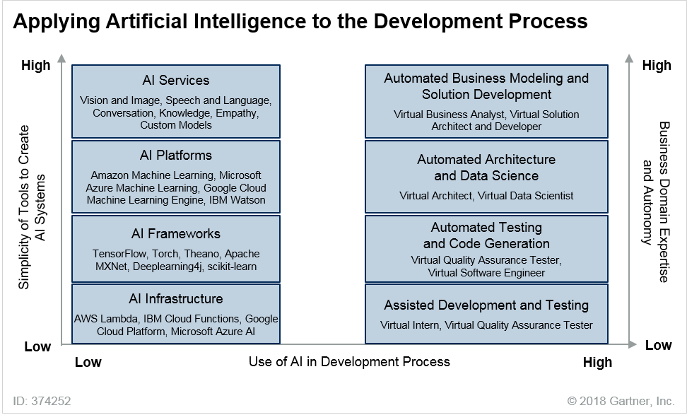

Source: Gartner (October 2018)

The Augmented Developer

The market is rapidly shifting from one in which professional data scientists must partner with application developers to create most AI-enhanced solutions to one in which professional developers can operate alone using predefined models delivered as a service. This provides the developer with an ecosystem of AI algorithms and models, as well as development tools tailored to integrating AI capabilities and models into a solution.

Some AI services are complete models that a developer can simply call as a function, pass the appropriate parameters and data, and obtain a result. Others may be pretrained to a high level but require some additional data to complete the training. For example, a model may be pretrained for image recognition but requires a training dataset to recognize a particular set of images. The advantage of these partially trained models is that they require much smaller datasets for training.

Not only does the evolution of these AI platforms and suites of AI services enable a wider range of developers to deliver AI-enhanced solutions, but it also delivers much higher developer productivity. This reduces waste and inefficiency in the software development life cycle. The pretrained models can be accessed via API calls or event triggers.

Competition is fierce between Microsoft, Google, Amazon, IBM and the major Chinese providers moving heavily into AI. Most of these services will be provided via the cloud, so organizations will need to decide whether:

* To let their existing choice of standard cloud infrastructure as a service (IaaS)/platform as a service (PaaS) cloud service provider dictate their choice of AI service providers
* To adopt a hybrid or multicloud service provider approach that brings in additional providers to augment the standard IaaS/PaaS platform

Competitors trying to break the Microsoft/Amazon duopoly — most notably Google — will move aggressively to differentiate themselves. They will do so with higher-level PaaS services, such as AI services, to gain traction for their underlying IaaS/PaaS services. Other specialized AI service providers that don’t have their own IaaS/PaaS platform will need to be aware of the performance and integration challenges of working with the main IaaS/PaaS providers. We expect to see ongoing partner ecosystems develop rapidly through 2021 as vendors battle in this area.

Determine the set of AI services to use from external providers. Next, define an architecture for how the organization’s data science teams will develop custom industry, domain and company-specific AI services and provide them as part of the AI service ecosystem to developers. This will make the cloud service provider decision even more complex, as it requires the selection of the underlying platforms, frameworks and infrastructure to build, train and deploy these models. We expect increasing demand to define these custom models in a standardized way so that they can be deployed in multiple environments.

Approach the selection of AI service, framework and platform strategically. This is important because of the rapid evolution of these services, the intense competition between service providers, and the potential complexity and cost of managing a highly heterogeneous AI service environment. To address these challenges, work closely with data science and application development teams, as well as technology innovation groups building advanced solutions.

The Automated Developer

Another level of opportunity and complexity arises as AI is applied to the development process itself to automate various data science, AD and testing functions. Through 2019, assisted development and testing will emerge to simplify these functions. These systems will provide basic technical knowledge and expertise and simple automation. By 2020, we expect more mainstream use of virtual software engineers to generate code. Through 2020, the augmented analytics trend will have impact by augmenting the data scientist function for the professional developer as well as the business user (the citizen data scientist). Google’s AutoML is one example of how augmented analytics will enable developers to automatically generate new models without the involvement of a professional data scientist. By 2022, at least 40% of new application development projects will have artificial intelligence co-developers on the team.

The near-term advances focus on the basic functional aspects of AD. Over time, the focus will shift from developing code to developing solutions that comprise nonfunctional aspects, including business domain expertise. Through 2022, advanced virtual data scientists and virtual business analysts will deliver some of this. Through 2023, virtual architects will deliver some of it. From 2025 onward, virtual solution architects and solution developers will do so as well. They will deliver such capabilities though AD and DevOps suites, but also through AI-enhanced solutions from business process management and the emerging “digital twin of the organization” trend. Technology

providers are beginning to deliver types of augmented development (see Note 2). As of 2018, these technologies are still embryonic.

Ultimately, highly advanced AI-powered development environments automating both functional and nonfunctional aspects of applications will give rise to a new age of the “citizen application developer.” In this new age, nonprofessionals will be able to use AI-driven tools to automatically generate new solutions. Tools that enable nonprofessionals to generate applications without coding are not new, but we expect that AI-powered systems will drive a new level of flexibility. They will enable nonprofessionals to create much more dynamic, open and complex solutions.

*Related Research:*

* “Hype Cycle for Data Science and Machine Learning, 2018”
* “Hype Cycle for Artificial Intelligence, 2018”
* “AI Will Alter Application Development — Things to Do Now”
* “2018 Planning Guide for Application Platform Strategies”
* “Integrating Machine Learning Into Your Application Architecture”
* “Market Guide for AI Portfolio Cloud Service Providers”

Trend No. 4: Digital Twins

A digital twin is a digital representation of a real-world entity or system. The implementation of a digital twin is an encapsulated software object or model that mirrors a unique physical object (see Note 3). Data from multiple digital twins can be aggregated for a composite view across a number of real-world entities such as a power plant or a city. The notion of a digital representation of real- world entities or systems is not new. Its heritage goes back to computer-aided design representations of physical assets or profiles of individual customers. The difference in the latest iteration of digital twins is:

* The robustness of the models with a focus on how they support specific business outcomes
* Digital twins’ link to the real world, potentially in real time for monitoring and control
* The application of advanced big data analytics and AI to drive new business opportunities
* The ability to interact with them and evaluate “what if” scenarios

Digital twins in the context of IoT projects are leading the interest in digital twins today. Well- designed digital twins of assets could significantly improve enterprise decision making. They are linked to their real-world counterparts and are used to understand the state of the thing or system, respond to changes, improve operations and add value (see Figure 5).

Figure 5. Digital Twins Are Digital Representations of Real-World Objects

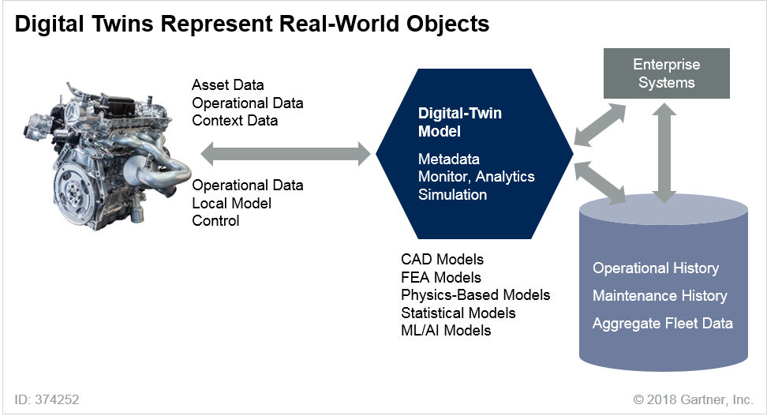

CAD = computer-aided design; FEA = finite element analysis; ML = machine learning Source: Gartner (October 2018)

By 2020, we estimate there will be more than 20 billion connected sensors and endpoints,9 and digital twins will exist for potentially billions of things. Benefits will include asset optimization, competitive differentiation and improved user experience in nearly all industries. By 2021, half of the large industrial companies will use digital twins, resulting in those organizations gaining a 10% improvement in effectiveness.

Organizations will implement digital twins simply at first. They will evolve them over time, improving their ability to collect and visualize the right data, apply the right analytics and rules, and respond effectively to business objectives. Digital-twin models will proliferate, with suppliers increasingly providing customers with these models as an integral part of their offerings.

Digital twins can drive significant business opportunities in several ways:

* **Improved maintenance and reliability.** The shift from preventive to predictive (condition- based) maintenance is a particularly high-value use of digital twins. Customer benefits include reduced maintenance-driven downtime and lowered operating and maintenance costs.
* **Business process/asset optimization.** Organizations can use digital twins to operate factories and increase operational efficiency. They can use them to plan for equipment service and to predict equipment failure, enabling them to repair equipment to prevent its failure. Organizations

can use feedback from the digital twin to dynamically reconfigure production processes in response to market demand or other factors.

* **Monetization of data and models.** Organizations can use data gleaned from digital twins to suggest new products to serve the machine as a customer, where the machine and its digital twin have a budget for approved services.
* **R&D.** Digital twins can aid innovation by providing insights into how products and services are used and how they can be improved. Organizations can use digital twins to enhance product development. They can do this by using them to simulate the behavior of new products based on the digital-twin insight from previous products, taking into consideration their cost, environment and performance.
* **New business models.** Digital twins offer the possibility of business models centered on guaranteed outcomes, such as specific asset performance guarantees. New business models may center on proactive advice. For example, automotive engineers could use digital twins, in conjunction with an analytics tool, to analyze how motorists drive a specific car to suggest new features to reduce accidents. Other models may center on potential new marketplaces for digital twins, interfaces and suitably sanitized datasets from digital twins.

Digital twins are built on the concept that virtual asset models coexist and are connected to real assets — they are twins. However, this concept isn’t limited to assets (or things). Digital analogs of real-world elements are growing along many dimensions. Like digital twins, these other digital entities often grow from metadata structures and models of things in the real world that are disconnected from it, or are, at most, connected only loosely to it. Over time, these digital representations/models will be connected more tightly to their real-world counterparts. They will be infused with more sophisticated AI-based models, as with digital twins for assets. The following will be used for advanced simulation, operations and analysis:

* Future models of humans that could include rich biometric and medical data
* Digital twins of an organization defining the details of business processes and ecosystem interactions
* Sophisticated models of places (buildings, cities), and people, processes and things supporting the trend toward smart spaces

Digital Twin of an Organization

A digital twin of an organization (DTO) visualizes the interdependence between functions, processes and key performance indicators to drive value. A DTO is a dynamic software model of a part of an organization. It relies on operational or other data to understand how an organization operationalizes its business model, connects with its current state, deploys resources and responds to changes to deliver expected customer value.

Like digital twins of things, DTOs hold the potential to create visibility, deliver situational awareness and support improved enterprise decisions. The four core elements of a DTO are:

* The operating model of the physical organization
* Data from and about the organization’s constituents
* Unique one-to-one alignment (between the digital twin and the organization)
* The ability to monitor the organization’s relevant constituents

A DTO combines several operations and disciplines. Making the business case to use a DTO requires an outside-in view of internal operations, leadership and, above all, vision and courage. Digital twins are a means to an end — they help create relevance to the data around a process. People work with a DTO to pursue decisions and actions based on the data collected through the digital twin. The graphical model of the DTO is a way to connect all events, data and information about the processes, as well as the behavior of people acting as resources within the DTO. DTOs can drive significant business opportunities in a number of ways:

* **Digital business transformation.** An organization has multiple customer interactions, operations, products, services, channels, roles, systems, applications, processes and resources. It needs a DTO to connect objectives with business operations, and provide the relevant guidance and monitoring, which in turn enables the organization to adapt to the continuously changing environment. A DTO supports DigitalOps, which combines process, decision and resource models to drive performance.10
* **Extending the IoT digital-twin concept.** Digital twins are part of the digital theme that describes an ever-increasing merger of the digital world and the physical world. The digital-twin trend focuses on creating the appropriate digital representations of the operations of physical assets in the real world. These digital twins may be as simple as a dashboard with critical performance indicators (such as a threshold temperature or vibration), or highly sophisticated, incorporating input from many sensors and external data. Organizations will use digital twins of people, processes, organizations, and environments for strategic and operational decision making, and advanced simulation. Examples include a digital twin of a city (for example, Singapore11), a digital twin of a factory (Bosch12), and a digital twin of a port (Rotterdam13).
* **Process mining.** Process mining is closely associated with augmented analytics. It aims to discover, monitor and improve real processes (that is, not assumed processes) by extracting knowledge from event logs readily available in information systems. Process mining can provide the data connection part of a DTO.

*Related Research:*

* “Digital Twins Will Impact Economic and Business Models”
* “Five Approaches for Integrating IoT Digital Twins”
* “Why and How to Design Digital Twins”
* “Create a Digital Twin of Your Organization to Optimize Your Digital Business Transformation Program”
* “DigitalOps Helps Connect Business Models to the Digital Business Platform”
* “Market Guide for Technologies Supporting a DTO”

Trend No. 5: Empowered Edge

Edge computing describes a computing topology in which information processing and content collection and delivery are placed closer to the sources and repositories of this information. Edge computing draws from the concepts of mesh networking and distributed processing. It tries to keep the traffic and processing local, with the goal being to reduce traffic and latency. As such, the notion of edge content delivery has existed for many years. The “where to process the data” pendulum has swung between highly centralized approaches (such as a mainframe or a centralized cloud service) and more decentralized approaches (such as PCs and mobile devices). Connectivity and latency challenges, bandwidth constraints, and greater functionality embedded at the edge favor distributed deployment models. The advantages of processing power and low costs of operating at hyperscale, coupled with the complexity of managing and coordinating thousands of geographically separated endpoints, favor the centralized model.

Much of the current focus on edge computing comes from the need for IoT systems to deliver disconnected or distributed capabilities into the embedded IoT world for specific industries such as manufacturing or retail. Widespread application of the topology and explicit application and networking architectures aren’t yet common. Systems and networking management platforms will need to be stretched to include edge locations and edge-function-specific technologies. Edge computing solves many pressing issues, such as high WAN costs and unacceptable latency. The edge computing topology will enable the specifics of digital business and IT solutions uniquely well in the near future.

Edge Computing and Cloud Computing Are Complementary Concepts

Many view cloud and edge computing as competing approaches. They view public cloud deployments as enjoying the economies of hyperscale, centralized data centers, with edge computing mandating processing to be pushed to the edge. But this is a misunderstanding of the two concepts. Cloud computing is a style of computing in which elastically scalable technology capabilities are delivered as a service using internet technologies. Cloud computing doesn’t mandate centralization. Edge computing brings the distributed computing aspect into the cloud style. Consider cloud and edge computing as complementary rather than competing concepts (see Figure 6).

Figure 6. Cloud and Edge Computing Are Complementary Concepts

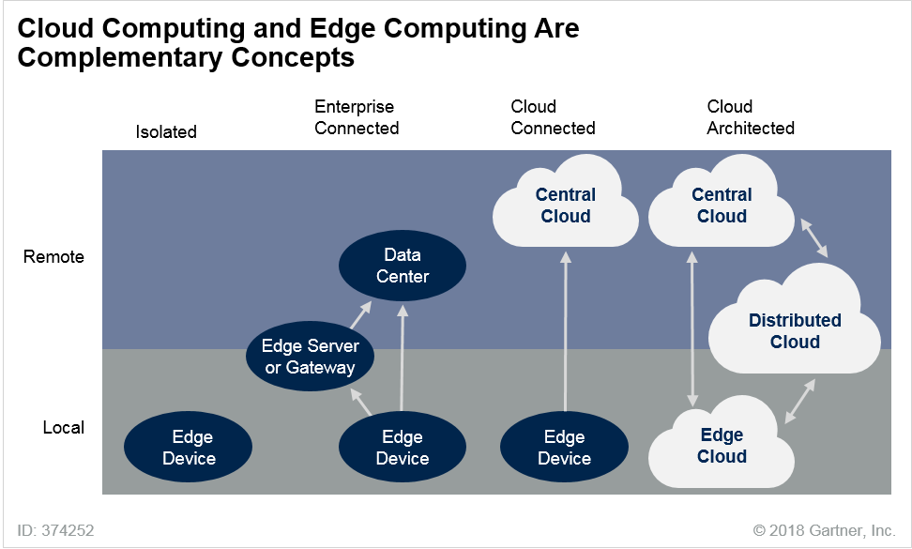

Source: Gartner (October 2018)

Some cloud implementations already use an approach that distributes functionality to the edge. Microsoft installs Office 365 services onto client devices on the edge cloud. Azure Stack installs a subset of Azure services on distributed cloud servers outside Microsoft’s cloud data centers. In July 2018, Google highlighted early implementations of Google Kubernetes Engine services on- premises.14 Amazon is extending its services into the IoT market with AWS Greengrass. We expect this approach will be used more frequently as cloud vendors push further into the IoT market, and IoT solution vendors adopt the cloud style to manage their solutions more effectively. Although the IoT is a strong driver for a cloud-to-the-edge approach, the approach will also benefit mobile and desktop environments. Longer term, edge implementations of hyperscaler-defined software stacks will create a continuum of solutions, from core to edge.

Exploiting Advanced Capabilities at the Edge

Through 2028, we expect a steady increase in the embedding of sensor, storage, compute and advanced AI capabilities in edge devices. However, the edge is a heterogeneous concept. It ranges from simple sensors and embedded edge devices to familiar edge computing devices such as mobile phones and highly sophisticated edge devices such as autonomous vehicles. Different types of edge devices used in different scenarios can have very different life spans, ranging from one year to 40 years. These factors combined with the rapid push by vendors to drive more functionality into edge devices create a complex and ongoing management and integration challenge.

Intelligence will move to the edge across a spectrum of endpoint devices including simple embedded edge devices (e.g., appliances, industrial devices), edge input/output devices (e.g., speakers, screens), edge computing devices (e.g., smartphones, PCs), and complex embedded edge devices (e.g., automobiles, power generators). These edge systems will connect with hyperscale back-end services directly or through intermediary edge servers or gateways (see Note 4).

Communicating to the Edge — The Role of 5G

Connecting edge devices with one another and with back-end services is a fundamental aspect of IoT and digital twins. The proliferation of millions of edge endpoints and the potential need to move large amounts of data from or to the edge make 5G an important communication technology for edge computing.

5G is the next-generation cellular standard after 4G (Long Term Evolution [LTE], LTE Advanced [LTE- A] and LTE Advanced Pro [LTE-A Pro]). Several global standards bodies have defined it — International Telecommunication Union (ITU), 3rd Generation Partnership Project (3GPP) and European Telecommunications Standards Institute (ETSI). The official ITU specification, International Mobile Telecommunications-2020 (IMT-2020), targets maximum downlink and uplink throughputs of 20 Gbps and 10 Gbps respectively, latency below 5 milliseconds, and massive scalability. New system architecture includes core network slicing as well as edge computing.

5G addresses three key technology communication aspects, each of which supports distinct new services, and possibly new business models (such as latency as a service):

* Enhanced mobile broadband (eMBB), which most providers will probably implement first.
* Ultrareliable and low-latency communications (URLLC), which addresses many existing industrial, medical, drone and transportation requirements where reliability and latency requirements surpass bandwidth needs.
* Massive machine-type communications (mMTC), which addresses the scale requirements of IoT edge computing.

Use of higher frequencies and massive capacity will require very dense deployments with higher frequency reuse. As a result, we expect that most 5G deployments will initially focus on islands of deployment, without continuous national coverage. Typically, by 2022, they won’t have reached the current geographic coverage of 4G in developed nations.

We expect that, by 2020, 4% of network-based mobile communications service providers (CSPs) will launch the 5G network commercially. Many CSPs are uncertain about the nature of the use cases and business models that may drive 5G. We expect that, from 2018 through 2022, organizations will use 5G mainly to support IoT communications, high-definition video and fixed wireless access (see “Emerging Technology Analysis: 5G”).

Identify use cases that definitely require the high-end performance, low latency or higher densities of 5G for edge computing needs. Map the organization’s planned exploitation of such use cases against the expected rollout by providers through 2023. Where gaps exist, evaluate the available

alternatives that may prove adequate and more cost-effective than 5G for particular use cases. Examples include low-power wide-area (LPWA), such as NarrowBand Internet of Things (NB-IoT), Long Range (LoRa), Sigfox and Wireless Smart Ubiquitous Networks (Wi-SUN).

*Related Research:*

* “The Edge Completes the Cloud: A Gartner Trend Insight Report”
* “How Edge Computing Redefines Infrastructure”
* “The Future Shape of Edge Computing: Five Imperatives”
* “Digital Business Will Push Infrastructure to the Edge”
* “Expand Your Artificial Intelligence Vision From the Cloud to the Edge”
* “Market Trends: Make Compelling 5G Technology Selections and Be First to Attain 5G Success”

Trend No. 6: Immersive Experience

Through 2028, the user experience will undergo a significant shift in how users perceive the digital world and how they interact with it. Conversational platforms are changing the way in which people *interact* with the digital world. Virtual reality (VR), augmented reality (AR) and mixed reality (MR) are changing the way in which people *perceive* the digital world. This combined shift in both perception and interaction models leads to the future immersive user experience. The model will shift from one of technology-literate people to one of people-literate technology. The burden of translating intent will move from the user to the computer. The ability to communicate with users across many human senses will provide a richer environment for delivering nuanced information.

How We Perceive the Digital World Is Changing

VR and AR are separate but related technologies. MR extends both approaches to incorporate the physical world in a more robust way (see Note 5). The visual aspect of the experience is important, but so are other sensory models, such as touch (haptic feedback) and sound (spatial audio). This is particularly so with MR in which the user may interact with digital and real-world objects while maintaining a presence in the physical world.

VR provides a computer-generated 3D environment that surrounds a user and responds to an individual’s actions in a natural way. This is usually through an immersive head-mounted display (HMD) that blocks the user’s entire field of vision. Gesture recognition or handheld controllers provide hand and body tracking, and touch-sensitive feedback may be incorporated. Positional tracking enables one or more participants to walk in a room untethered. Room-based systems that provide a deeper sense of immersion deliver a 3D experience for multiple participants or one in which a person can walk in a room untethered.

AR is the real-time use of information in the form of text, graphics, video and other virtual enhancements integrated with real-world objects. It’s presented using an HMD or mobile device. This overlaying of virtual-world elements on a real-world background differentiates AR from VR. AR

aims to enhance users’ interaction with the real physical environment, rather than separating them from it. This definition also applies to MR. In general, MR enables people to interact with virtual objects.

VR and AR Can Help Increase Productivity

Interest and excitement are high, resulting in multiple VR applications. Consumer-focused applications provide advanced entertainment, such as video games and 360-degree spherical videos. For businesses, this means the market is nascent with primary use cases including field services/remote workers, manufacturing/warehousing, training and design visualization, and the provision of hands-free information. The next generation of headsets is wireless, can sense shapes and track the user’s position in the environment, enabling more practical and realistic applications. Only by examining and exploiting real-life scenarios can you drive tangible business benefits with these technologies.15

Smartphones can also be an effective platform for mobile VR and AR. As with ARCore and ARKit, Google’s Cardboard and Daydream and Samsung’s Gear VR also use a smartphone as their computing platform. Snap your smartphone into one of these low-cost HMDs, hold it to your eyes, and see and interact with compelling virtual worlds. You don’t even have to use one of these in an HMD configuration to experience AR — it can combine digital overlays on a real-world video experience. The device’s screen becomes a “magic window” that displays graphics overlaid on top of real-world things. It superimposes contextual information that blends augmented data on top of real-world objects (such as hidden wiring superimposed on an image of a wall). Although this approach has significant limitations compared with more robust HMD-based approaches, it represents a widely available and cost-effective entry point for occasional use.

MR will become the immersive user experience of choice as the technology matures. It provides a compelling technology enabling people to view and interact with their world. MR headsets include Microsoft HoloLens and Magic Leap One.

Although the potential of VR, AR and MR is impressive, there will be many challenges and roadblocks. Identify key target personas and explore targeted scenarios. For example, explore the needs of, and business value for, a target user in different settings, such as at home, in a car, at work, with a customer or traveling. By 2022, 70% of enterprises will be experimenting with immersive technologies for consumer and enterprise use, and 25% will have deployed them to production.

How We Interact With the Digital World Is Changing

A conversational platform provides a high-level design model and execution engine in which user and machine interactions occur. As the term “conversational” implies, these interfaces are implemented mainly in the user’s spoken or written natural language. In time, other input/output (I/O) mechanisms will be added to exploit sight, taste, smell and touch for multichannel interaction. The use of expanded sensory channels will support advanced capabilities, such as emotion detection through facial expression analysis and human health status through olfactory analysis. But exploitation of these other sensory channels will be isolated and limited through 2023.

Conversational platforms are most recognizably implemented in:

* VPAs, such as Amazon Alexa, Apple’s Siri, Google Assistant and Microsoft’s Cortana
* Virtual customer assistants (VCAs), such as IPsoft’s Amelia, Watson Virtual Agent, and VCAs from Artificial Solutions, Interactions, Next IT and Nuance
* Chatbot frameworks, such as Amazon Lex, Dialogflow from Google, IBM Watson Assistant and Microsoft Bot Framework

Interactions in conversational platforms are typically informal and bidirectional. The interaction may be a simple request or question (such as “What’s the weather forecast?” or “What time is it?”) with a simple result or answer. Alternatively, it may be a structured interaction (such as that required to book a restaurant table or hotel room). As the technology matures, extremely complex requests will be possible. For example, the conversational platform may be able to collect oral testimony from crime witnesses, resulting in the creation of a suspect’s image.

Conversational platforms have reached a tipping point: The usefulness of the systems has exceeded the friction of using them. But they still fall short. Friction is created when users need to know which domains the UI understands and what its capabilities are within those domains. The challenge that conversational platforms face is that users must communicate in a very structured way. This is often a frustrating experience. Rather than enabling a robust two-way conversation between the person and the computer, most conversational platforms are mainly one-directional query or control systems that produce a very simple response. Over time, more conversational platforms will integrate with growing ecosystems of third-party services that will exponentially drive the usefulness of these systems. A primary differentiator among conversational platforms will be the robustness of their conversational models and the API and event models used to access, invoke and orchestrate third-party services to deliver complex outcomes.

Through 2020, application vendors will increasingly include conversational platforms in packaged applications. They will do so to maintain a direct channel to their users, rather than being intermediated by a conversational platform they don’t control. We expect ongoing battles between application vendors and providers of general-purpose conversational platforms through 2023.

The shifting user experience will create many new digital business opportunities, but will also pose significant IT security and management challenges. The realization of the continuous, immersive and conversational user experience will require a profoundly better appreciation of privacy and permission. Devices that are “always listening” may collect information from users without their consent.

The Future Will Be an Ambient Experience

Over time, we will shift from thinking about individual devices and fragmented UI technologies to a multichannel and multimodal experience. The multimodal experience will connect people with the digital world across hundreds of edge devices that surround them. These will include traditional computing devices, wearables, automobiles, environmental sensors and consumer appliances. The multichannel experience will use all human senses as well as advanced computer senses (such as

heat, humidity and radar) as appropriate across this rich sea of multimodal devices. This multiexperience environment will create an ambient experience in which the spaces that surround us define “the computer” rather than the individual devices. In effect, the environment is the computer.

The integration of VR and AR with multiple mobile, wearable, IoT and sensor-rich environments and conversational platforms will extend immersive applications beyond isolated and single-person experiences. Rooms and spaces will become active with things, and their connection through the mesh will appear and work in conjunction with immersive virtual worlds. Imagine a warehouse that can not only recognize the presence of workers, but also help them understand the state of its equipment, and can visually point out parts requiring replacement.

The term “immersive, ambient user experience” will appear only slowly over the next 10 years and beyond (see Figure 7). The long life cycles of many of the assets in our environment and the complexity of having a wide variety of creators develop random elements independently will be an enormous barrier to seamless integration. There is no equivalent of the internet and the web with its attendant identifiers, formats and protocols to provide easy integration across these spaces. Don’t expect automatic plug-and-play of devices, applications and services. Instead there will be proprietary ecosystems of devices. Focus on targeted use of conversational platforms and other specialized interaction channels, as well as AR/VR and other perception channels, for very specific use cases. These may be targeted experiences on specific devices, but opportunities will grow for more robust scenarios across multiple devices and sensory channels to support very specific environments. The application of virtual assistants and independent agents, along with the development of digital twins and these immersive experience enablers, will drive the smart spaces trend.

Figure 7. The Future of the User Experience

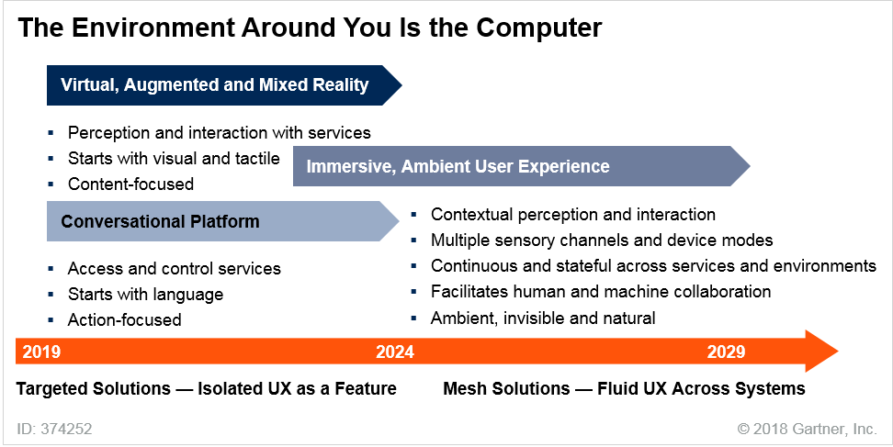

UX = user experience

Source: Gartner (October 2018)

*Related Research:*

* “Hype Cycle for Human-Machine Interface, 2018”
* “Architecture of Conversational Platforms”
* “Architecting and Integrating Chatbots and Conversational User Experiences”
* “Getting Started Developing Virtual Reality Experiences”
* “Market Guide for Augmented Reality”
* “Market Insight: Mixed-Reality Immersive Solutions Are the Ultimate User Experience for Everyone”

Trend No. 7: Blockchain

A blockchain is a type of distributed ledger. A distributed ledger is an expanding chronologically ordered list of cryptographically signed, irrevocable transactional records shared by all participants in a network. Each record contains a time stamp and reference links to the previous transactions. With this information, anyone with access rights can trace a transactional event, at any point in its history, belonging to any participant. Blockchain and other distributed-ledger technologies provide trust in untrusted environments, eliminating the need for a trusted central authority. Blockchain has

become the common shorthand for a diverse collection of distributed ledger products, with more than 70 offerings in the market.

Blockchain provides business value by removing business friction. It does this by making the ledger independent of individual applications and participants and replicating the ledger across a distributed network to create a consensus-based authoritative record of significant events.

Everyone with a particular level of permissioned access sees the same information at the same time. Integration is simplified by having a single shared blockchain model. Blockchain also enables a distributed trust architecture that allows untrusted parties to undertake commercial transactions, and create and exchange value using a diverse range of assets (see Figure 8).

Figure 8. Key Elements of Blockchain

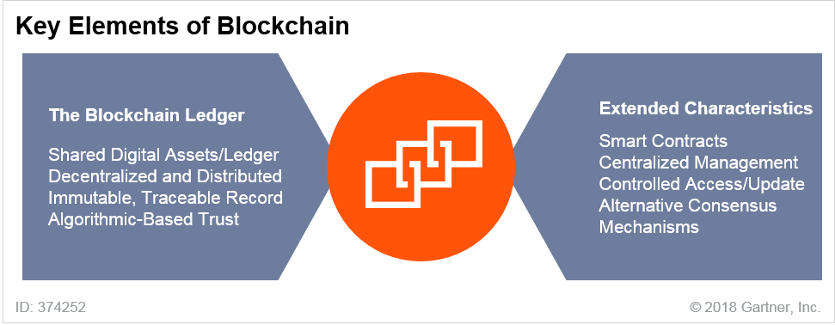

Source: Gartner (October 2018)

Blockchain represents an alternative to the centralized trust models that make up most record keepers of value. Today, we place trust in banks, clearinghouses, governments and many other institutions as central authorities with the “single version of the truth” maintained securely in their databases. The centralized trust model adds delays and friction costs (commissions, fees and the time value of money) to transactions. Blockchain provides an alternative trust model. Using a public blockchain removes the need for central authorities in arbitrating transactions.

Blockchain forces EA and technology innovation leaders to rethink the notion of value exchange in a world of decentralized trust. The hype surrounding blockchain originally focused on the financial services industry. But blockchain has many potential applications beyond financial services, including government, healthcare, manufacturing, supply chain, content distribution, identity verification and title registry.

Blockchain promises to reshape industries by enabling trust, providing transparency and reducing friction across business ecosystems, potentially lowering costs, reducing transaction settlement times and improving cash flow. Assets can be traced to their origin, significantly reducing the opportunities for substitutions with counterfeit goods. Asset tracking also has value in other areas, such as tracing food across a supply chain to more easily identify the origin of contamination or

track individual parts to assist in product recalls. Another area in which blockchain has potential is identity management. Smart contracts can be programmed into the blockchain where events can trigger actions; for example, payment is released when goods are received.

Many technology providers and consortia-led initiatives are offering and developing solutions that do not implement all the attributes of blockchain. These blockchain-inspired offerings are often based on more traditional, nonblockchain technologies and largely replicate existing transaction messaging infrastructures or distributed databases without decentralization as a key design principle. In general, they use just three main components of the blockchain concept: some version of a centralized notary or distributed or replicated data store, cryptography (hashing/signing) and a messaging layer. They are almost exclusively bundled for private or enterprise deployment and they lack tokenization and decentralization.

These blockchain-inspired solutions are positioned as a means to achieve operational efficiency by automating business processes, or by digitizing records. They also have the potential to enhance sharing of information among known entities, as well as potentially improve opportunities for tracking and tracing physical and digital assets. Organizations focused on blockchain-inspired solutions may be able to address technology and business challenges that existing legacy solutions cannot address, such as fraud mitigation, reconciliation reduction, and more effective (secure) data sharing, replication and distribution.

Blockchain-inspired approaches enable an organization to proceed with blockchain, while avoiding expensive and potentially painful changes in business model and process. However, such approaches miss the value of true blockchain disruption and may increase vendor lock-in.

Organizations choosing this option should understand the limitations and be prepared to move to complete blockchain solutions over time. They should also recognize that the same outcomes may be achieved with more efficient and tuned use of existing nonblockchain technologies.

Complete blockchain solutions face key challenges that will undermine the delivery of robust scalable solutions through 2023. Blockchain technologies and concepts are immature, poorly understood and unproven in mission-critical, at-scale business operations. This is particularly so with the more complex elements that support more sophisticated scenarios.

Despite the challenges, the significant potential for disruption means you should probably begin evaluating blockchain, even if you don’t aggressively adopt the technologies in the next few years. Blockchain will create $3.1 trillion in business value by 2030.16 A practical approach to blockchain development demands:

* A clear understanding of the business opportunity and potential industry impact
* A clear understanding of the capabilities and limitations of blockchain technology
* A trust architecture
* The necessary skills to implement the technology

Develop clear language and definitions for internal discussions about the nature of the technology. Recognize that the terminology surrounding blockchain is in flux. This uncertainty masks the

potential suitability of technology solutions to meet business use cases. Consequently, use extreme caution when interacting with vendors that have ill-defined/nonexistent blockchain offerings. Identify exactly how the term “blockchain” is being used, both internally and by providers.

Monitor distributed-ledger developments, including related initiatives, such as consensus mechanism development, sidechains and blockchains. Resources permitting, consider distributed ledger as proof of concept (POC) development. But, before starting a distributed-ledger project, ensure your team has the business and cryptographic skills to understand what is and isn’t possible. Identify the integration points with existing infrastructures to determine the necessary investments, and monitor the platform evolution and maturation.

*Related Research:*

* “Hype Cycle for Blockchain Technologies, 2018”
* “Blockchain Technology Spectrum: A Gartner Theme Insight Report”
* “The Future of Blockchain: 8 Scalability Hurdles to Enterprise Adoption”
* “Use Gartner’s Blockchain Conceptual Model to Exploit the Full Range of Possibilities”
* “Top Applications for Blockchain for IoT in 2018 and 2019”
* “Blockchain Solutions in Supply Chain: 2018 Market Insight”

Trend No. 8: Smart Spaces

A smart space is a physical or digital environment in which humans and technology-enabled systems interact in increasingly open, connected, coordinated and intelligent ecosystems. Multiple elements — including people, processes, services and things — come together in a smart space to create a more immersive, interactive and automated experience for a target set of personas or industry scenarios.

This trend has been coalescing for some time around elements such as smart cities, digital workplaces, smart homes and connected factories. We believe the market is entering a period of accelerated delivery of robust smart spaces, with technology becoming an integral part of our daily lives, whether as employees, customers, consumers, community members or citizens. AI-related trends, the expansion of IoT-connected edge devices, the development of digital twins of things and organizations, and the maturing of blockchain offer increasing opportunities to drive more connected, coordinated and intelligent solutions across target environments (see Figure 9).

Figure 9. Smart Space Evolution

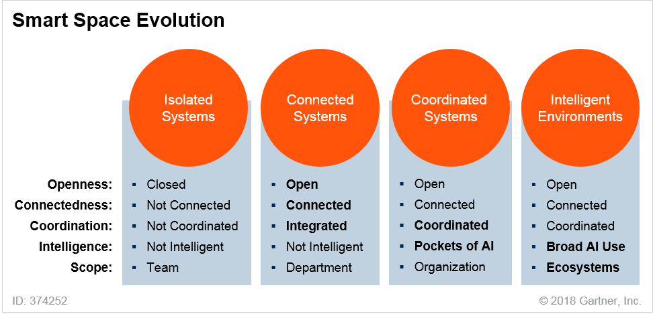

Source: Gartner (October 2018)

Individual organizations have long used technology for targeted purposes, but with the supporting systems typically closed and isolated from one another. As systems move to more dynamic coordination, organizations are applying AI and other technologies to create a much more flexible and autonomous level of coordination among systems. This is particularly so as the IoT phenomenon drives computing from isolated desktops and mobile devices into the world around us. Changes in the user experience are also changing how people interact with one another and with systems in a smart space. Smart spaces are evolving along five key dimensions:

* **Openness.** Openness refers to the degree of accessibility to the elements in a smart space. For example, in a closed model, individual applications or systems in a smart space would be isolated from one another with no sharing of data. Alternatively, if data were shared, it would be shared in a controlled and proprietary way. In contrast, in an open model, systems would be aware of one another, with data exposed and accessible to a wide audience through standardized mechanisms. Trends in open data formats, identifiers and protocols, as well as the work of open-source communities, are driving this aspect of smart spaces.
* **Connectedness.** Connectedness refers to the depth, breadth and robustness of the links between the elements in a smart space. Connectedness is closely related to openness. If there’s no connection, there’s no access to any of the functions or data of an application in the smart space, other than the predefined user interface. Such a system would be closed. As the mechanisms to access the attributes, data and functions of an application increase, the degree of openness increases. Increasing the granularity of the accessible attributes, data and functions also increases connectedness. Trends such as the IoT, IoT platforms, digital twins,

edge computing, APIs and API gateways, and mesh app and service architecture (MASA) all contribute to greater connectedness in a smart space.

* **Coordination.** Coordination refers to the depth and robustness of coordination between the elements in a smart space. Coordination is a more active aspect of smart spaces that builds on connectedness. While connectedness looks at the opportunity to connect various elements, coordination looks at the actual level of interaction and cooperation between the elements. For example, two applications operating in a smart space that shared login credentials would have a very low coordination score. However, if they also shared data and had tightly integrated process execution, they would have a much higher coordination score. Trends such as MASA, APIs and events also factor into coordination. So does blockchain, which offers a mechanism to dramatically reduce business friction between elements in a smart space through a shared ledger and smart contracts.
* **Intelligence.** Intelligence refers to the use of machine learning and other AI techniques to drive automation into the smart space and deliver services to augment the activities of people in it. Intelligence can manifest itself in the form of autonomous things or augmented intelligence, including augmented analytics. An important aspect is the use of AI to:
  + Help users in the smart space
  + Deliver immersive experiences to enhance how users perceive and interact with other elements in the smart space
* **Scope.** Scope refers to the breadth of a smart space and its participants. A smart space with a very narrow scope would focus on a single team within a department of a large organization. A smart space with a broader scope might focus more across the organization but within a bounded problem space. A smart space with an even broader scope might include elements external to the organization with an ecosystem of participants. Openness, connectedness and coordination set the stage for increasing the scope of a smart space. Intelligence promotes simplified access and automated management as the scope of a smart space increases.

In the long term, smart spaces will evolve to deliver intelligent environments in which multiple entities coordinate their activities in digital ecosystems and drive use cases or contextualized specific service experiences. In the ultimate manifestation of a smart space in the intelligent environment phase, there will be rich digital-twin models of people, processes and things across a city. Event-driven structures will replace predefined hard-coded integration points. Virtual assistants and independent agents will monitor and coordinate activities across multiple systems inside the organization or government entities and across multiple entities. Open data exchanges and the use of blockchain will reduce friction between different players in the ecosystem and the systems they use. It will be possible to add new capabilities to existing environments without upgrading the entire infrastructure.

Meanwhile, individuals operating in smart space ecosystems will use ever-expanding IoT edge devices and more immersive experiences. Technology will seem to fade into the background around them. Instead of using computers, the entire world around them will be their computer. This long- term smart space intelligent environment model won’t exist until 2028 at the earliest. However, organizations can achieve it much sooner in more narrowly defined industry scenarios with a

targeted set of personas and processes. Individual elements will evolve rapidly through 2023, spawning this new phase of smart spaces.

Smart City Spaces Lead the Way

Smart cities represent the most extensive example of the shift from isolated systems to intelligent environments. The vision behind smart cities is to create transparency into urban quality of life, promoting citizen engagement and self-development. The smart city is a framework or an invitation to collaborate, not a set of technologies or business strategies. It describes the collaboration and ecosystem surrounding the development of contextualized services for users in an urban environment. Well-designed smart cities aim to achieve holistic objectives and focus on intelligent urban ecosystems.

In the first wave of smart cities, technology providers were pushing end-user organizations to invest in individual POCs for the IoT, asset management or cost savings. Now, in the second wave, there is a shift to avoid the massive complexity of individual POCs and backward integration of new systems into existing systems. The focus is more on connected and coordinated systems with open and extensible capabilities.

Intelligent ecosystems are also being developed in urban revitalization zones, industry zones and brownfield sites. In these instances, the business or user/use case focus is on targeting real estate development or new living experiences for mixed community and social networking purposes. In emerging economies, industrial parks that combine business, residential and industrial communities are being built using the intelligent urban ecosystem frameworks, with public-private partnerships leading the technology and experience development. All sectors link to social and community collaboration platforms with IT and data exchange. Greenfield smart cities and neighborhoods are increasingly gaining attention from partnerships of city and real estate developers that want to create digital and intelligent smart city projects.17 These greenfield smart cities will incorporate the city vision into a design and implementation roadmap to deliver a smart space ecosystem.

Smart Spaces Are a Journey, Not a Destination

Smart spaces are a natural evolution from isolated, independent systems to intelligent, comprehensive environments. They bring together many technologies and trends to create an experience for targeted personas or industry scenarios. Smart cities are one manifestation of the concept, with digital workplaces, smart factories, smart agriculture and smart hospitals also on the horizon.

Smart spaces are the result of trends that can’t be ignored. Prepare for smart spaces by developing connected, interactive and intelligent environments on a scale that tests the concept but can expand to the larger environment.

*Related Research:*

* “Hype Cycle for Smart City Technologies and Solutions, 2018”
* “Turning Smart Cities Into Intelligent Urban Ecosystems”
* “Predicts 2018: Future of Supply Chain Operations”
* “Hype Cycle for Innovation in Manufacturing Industries, 2018”
* “Digital Workplace Applications Primer for 2018”
* “Hype Cycle for the Digital Workplace, 2018”

Trend No. 9: Digital Ethics and Privacy

Digital ethics and privacy are growing concerns for individuals, organizations and governments. Consumers are increasingly aware their personal information is valuable and are demanding control. Organizations recognize the increasing risk of securing and managing personal data, and governments are implementing strict legislation to ensure they do.

While the private sector is increasingly bound by privacy legislation, law enforcement and security services have far fewer controls. Police services use facial recognition to identify people of interest in real time. They use automatic number plate recognition (ANPR) to track vehicles of interest. They also use data from fitness trackers to establish people’s location and heart rate at the time of a crime.18 They’ve even used Face ID to unlock a suspect’s phone during an investigation.19 With billons of endpoints collecting information, law enforcement can identify who you are, where you are, what you’re doing and even what you’re thinking.

People are increasingly concerned about how their personal information is being used by organizations in both the public and private sector, and the backlash will only increase for organizations that are not proactively addressing these concerns.

Any discussion on privacy must be grounded in the broader topic of digital ethics and the trust of your customers, constituents and employees. While privacy and security are foundational components in building trust, trust is actually about more than just these components. As defined by Oxford Dictionaries, “trust” is a firm belief in the reliability, truth or ability of someone or something. Trust is the acceptance of the truth of a statement without evidence or investigation. Ultimately an organization’s position on privacy must be driven by its broader position on ethics and trust. Shifting from privacy to ethics moves the conversation beyond “are we compliant” toward “are we doing the right thing.” The move from compliance-driven organizations to ethics-driven organizations can be described as the hierarchy of intent (see Figure 10).

Figure 10. The Hierarchy of Intent

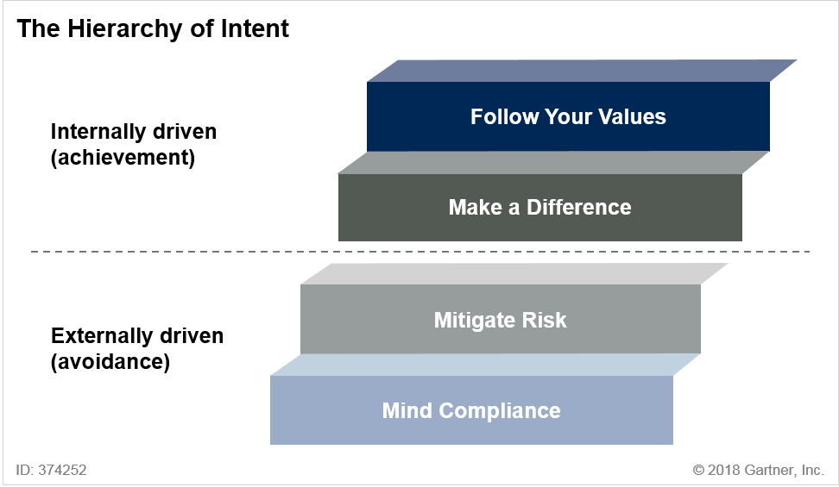

Source: Gartner (October 2018)

**Mind compliance:** As the lowest level in the hierarchy, minding compliance is externally driven and focused on avoiding issues. Here, enterprises make decisions about the use of technology based on what is allowed. If there is no rule against what is proposed, it is allowed.

The EU’s General Data Protection Regulation (GDPR) redefines the ground rules for privacy and has had a global impact. It allows for fines of up to 4% of annual global revenue or €20 million, whichever is highest. We expect that before year-end 2021, more than a billion euros in sanctions for GDPR noncompliance will have been issued.

Many other nations are in the process of developing or implementing privacy legislation, and this evolving patchwork of privacy laws around the world will continue to challenge organizations in the way they interact with customers, citizens and employees.

Legislation is also driving data residency issues in jurisdictions including China, Russia, Germany and South Korea. Organizations must assess the data residency requirements of the countries in which they operate to determine a data residency strategy. Local data centers are an option, but often an expensive one and in many cases there are legal and logical controls available under which safe cross-border transfers of personal data can be possible. Cloud service providers are locating data centers in countries where data residency is either driven by legislation or by customer preferences.

**Mitigating risk:** This level focuses on the risk an enterprise is willing to take without harming itself. This includes assessing the risk of doing harm to others and of “getting caught” doing something that leads to public embarrassment and reputational risk.

Emerging technologies such as the IoT and AI, along with an explosion of third-party data, exponentially increase both the opportunities and the attack surface for this data. Cambridge Analytica (now insolvent) infamously used data from Facebook to influence voter behavior through microtargeting advertisements.20

People are justifiably concerned about the use of their personal data, and are starting to fight back. Misguided personalization attempts, media coverage and lawsuits have made one thing clear to customers: Their data is valuable and they want to take back control. Customers are “disappearing” by deflecting, hiding, camouflaging and fading. They’re opting out of services, paying in cash or bitcoin, using VPNs to mask their location, providing false information or simply fading out of the relationship.

Right to be forgotten (RTBF) legislation exists in many jurisdictions including Europe, South Africa, South Korea and China. It requires companies to remove data about individuals on request. The right to data portability empowers customers to more easily take their personal data — and business — elsewhere. The highly valuable personal information that organizations have spent a decade to effectively leverage is disappearing. Failure to incorporate privacy into a personalization strategy can bring unwanted results such as customer churn, lack of loyalty, distrust, as well as brand reputational damage. In some cases, regulatory intervention could occur if customers feel their privacy is being threatened.

Companies that misuse personal data will lose the trust of their customers. Trustworthiness is a key factor in driving revenue and profitability. Building customer trust in an organization is difficult, but losing it is easy. However, organizations that gain and maintain the trust of their customers will thrive. By 2020, we expect that companies that are digitally trustworthy will generate 20% more online profit than those that aren’t.

**Making a difference:** Ethical considerations can be used to make a difference for customers, industries or even society at large. For commercial enterprises, this can mean competitive differentiation by creating a value proposition out of ethics. For public-sector institutions, this can mean creating value for citizens based on what they are expecting.

An example of making a difference at a commercial enterprise would be implementing the principles of “privacy by design” to position your products and services as more privacy-friendly than those of competitors. This creates a value proposition based on trust. A 2017 survey indicates, 87% of consumers say they will take their business elsewhere if they don’t trust that a company is handling their data responsibly.21

**Following your values:** This refers to decision making driven by your moral compass. What does your brand stand for? What company values do you have? What is your “brand permission”?

Following your values comes down to being able to look yourself in the mirror and feel convinced you are doing the right thing. Are you treating customers, employees or citizens as you would

expect to be treated? The successful use of technology is not to maximize its utility for the organization at the expense of the customer, rather it is to figure out how to get the most value out of it for both the organization and the individuals it depends on.

*Related Research:*

* “Modern Privacy Regulations Could Sever or Strengthen Your Ties With Customers”
* “The CIO’s Guide to Digital Ethics: Leading Your Enterprise in a Digital Society”
* “Introducing Digital Connectivism: A New Philosophy for the Digital Society”
* “Use These Privacy Deliverables in Every IT Development Project”
* “Build for Privacy”
* “Hype Cycle for Privacy, 2018”

Trend No. 10: Quantum Computing

A commercially available, affordable and reliable quantum computing (QC) product or service can transform an industry. One example is pharmaceuticals, in which new drug compounds can be quickly derived and the segmentation of customers or populations can occur in local governments, airlines, retail and financial services. Gartner inquiries about QC have more than tripled each year for the past two years. Three factors are driving this interest:

* The threat of QC to cryptography
* Curiosity about the capabilities of QC and time frames for specific applications
* QC’s potential use as a competitive advantage

Quantum computing is a type of nonclassical computing that operates on the quantum state of subatomic particles (for example, electrons and ions) that represent information as elements denoted as quantum bits (qubits). A qubit can hold all possible results simultaneously (superposition) until read. Qubits can be linked with other qubits, a property known as entanglement. Quantum algorithms manipulate linked qubits in their undetermined, entangled state. The qubits resolve to a solution when read. Quantum computing is a massively parallel process that scales exponentially as you add additional qubits.

Imagine a library that includes every book ever written. A conventional computer would read each book sequentially to search for a particular phrase. Quantum computers read all the books simultaneously. The parallel execution and exponential scalability of quantum computers means they excel with problems too complex for a traditional approach or where a traditional algorithm would take too long to find a solution. Specific applications could include machine learning, route optimization, image analysis, biochemistry and drug discovery, materials science, and code breaking (as prime number factoring).

Industries such as automotive, financial, insurance, pharmaceuticals, military and research organizations have the most to gain from the advancements in quantum computing. Key potential applications of quantum computing include:

* **Optimization.** Optimization problems are most likely the No. 1 use case for QC. QC optimization can potentially help with machine learning, AI and neural networks. The promise is that they will be able to dramatically improve the acceleration of pattern recognition as the technology matures through 2023.
* **Materials science.** QC could be used to analyze complex atomic interactions, enabling faster discovery of new materials that will enable new economies and new discoveries. Creating new patentable materials is a major potential source of profits for early adopters in key sectors.
* **Chemistry.** QC could enable quantum simulation at an atomic scale allowing for design of new chemical processes.
* **Personalized medicine.** QC could be used to model molecular interactions at atomic levels to accelerate time to market for new cancer-treating drugs. QC could accelerate and more accurately predict the interaction of proteins leading to new pharmaceutical methodologies.
* **Biology.** QC could be used for native quantum simulation of processes such as photosynthesis or for modeling energy systems and interactions. QC could help accelerate the development of new or improve fertilizers helping improve the world’s food sources.

Quantum Computing and Security

QC, in the distant future, will compromise today’s cryptographic key exchange protocols. Quantum safe cryptography is emerging, implemented in software, and should be a medium-term strategic initiative for organizations where data must be protected over decades. The National Institute of Standards and Technology (NIST) has decided that it is prudent to begin developing standards for postquantum cryptography. NIST is hosting an open contest for selecting recommended Post- Quantum Encryption Standardization algorithms and is expected to make a recommendation in 2021.

The National Security Agency (NSA) has issued an order that U.S. national security employees and vendors must, “in the not-too-distant future,” begin overhauling their encryption to guard against the threat posed by quantum computers. Because national security information must be protected for decades, the agency says new encryption needs to be in place before these machines arrive. NIST has begun looking for replacement algorithms for RSA and elliptic-curve cryptography and has begun issuing new guidance for key and hash lengths. QC will cause a re-evaluation of the security products that address encryption and hashing.

Quantum computing is not only a threat to current security mechanism; it holds potential for improved security as well. In healthcare, homomorphic encryption has emerged as a desired solution for privacy and for processing confidential data. Homomorphism is a property of some forms of quantum-resistant encryption that allows computational operations (addition and multiplication) to take place on encrypted text, and the result of those operations appears in the decrypted text. This supports the processing of data that cannot be read, even when intercepted.

Quantum Computer Maturity

Quantum computers are not general-purpose computers. Rather, they are accelerators capable of running a limited number of algorithms with orders of magnitude of speedup compared with conventional computers. Because of the complex and experimental nature of QC hardware, we recommend the use of quantum as a service from vendors such as IBM and D-Wave Systems, rather than buying a quantum computer. QC is driving significant activity from providers such as 1QBit, Alibaba Cloud, D-Wave Systems, Google, IBM, Microsoft, QC Ware, QinetiQ and Rigetti Computing. There is also a great deal of research underway at many university and corporate labs. We previously expected that QC would reach market maturity on our Hype Cycle in 10 or more years, but we’ve revised that estimate to five to 10 years.22

These advances, as well as the potential impact of QC for key applications, make this an important trend for organizations looking to address specific complex problems to add to their long-term strategic planning. However, significant hype exists and many challenges remain:

* **Quantum errors.** Minimizing quantum errors is important when it comes to quantum advantage. Scaling universal gate model quantum computers to practical useful sizes will require the incorporation of quantum error correction schemes. It’s believed that meaningful work can be achieved when quantum computers reach 100 to 300 logical qubits with some complex problems requiring substantially more (see Figure 11).
* **Decoherence.** When a quantum system is not perfectly isolated from the environment but is in contact with its surroundings, coherence decays with time. This process is called quantum decoherence. Quantum algorithms execute only when coherence is in place. Currently, only very short coherence times are possible.
* **Lack of standard development languages.** QC development languages will be very different from existing development languages because of the quantum nature of the system. The race is on to recruit and train developers and to build mind share for the products to become the standards as the hardware progresses.

Figure 11. Quantum Computing Timeline

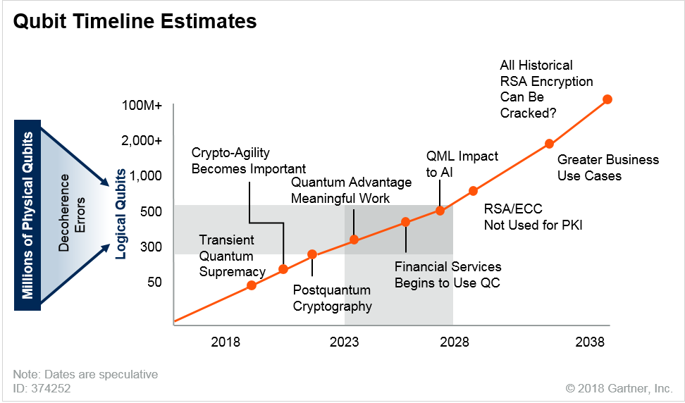

Source: Gartner (October 2018)

Activity has been accelerating, and will continue to do so, in QC. In September 2018, Rigetti Computing announced its Quantum Cloud Service (QCS) and a 128-qubit processor.23 Google has a 72-qubit chip24 and IBM offers QC as a Service (QCaaS) and a 50-qubit processor.25 D-Wave also offers QCaaS with access to Ocean (D-Wave’s SDK environment), shared live code and sample industry examples addressing real business problems with quantum algorithms.26 Microsoft is working on a topological qubit.27 These vendors are staking out key territory in the development of QC programming languages. The quantum computer race has started.

Don’t Ignore QC, but Proceed With Caution

Start planning for QC by increasing understanding of how it can apply to real-world business problems. Learn while the technology is still in an emerging state. Identify real-world problems where QC has potential and consider the possible impact on security. But don’t believe the hype that it will revolutionize either of these areas in the next few years. Most organizations should learn about and monitor QC through 2022 and perhaps exploit it from 2023 or 2025. Organizations with significant supercomputer needs, where specific quantum algorithms could provide advantage, may begin light experimentation today using QCaaS. Track provider advances and look for clear progress in dealing with error rates, coherence times, and QC development environments and algorithms. Leverage QC vendor customer assistance programs to identify opportunities to deliver

practical value back to the organization. By 2023, 20% of organizations will be budgeting for quantum computing projects compared to less than 1% today.

QC is nascent and likely to change dramatically through 2028, both in technological and architectural advancements and in algorithmic discoveries. Programming architectures and tools are proprietary and will change as the industry matures. Quantum algorithm development is the weak point of adoption. The scope and applicability of use cases will probably expand QC’s value for those who wait. Wait for QC to mature before buying it and deploying it into production, but don’t ignore QC while waiting for it to mature. Actively monitor industry progress and anticipate potentially disruptive opportunities and challenges. Identify and inventory dependency on quantum-vulnerable cryptographic algorithms, and prepare for their mitigation or replacement by creating an inventory of application dependencies. Evaluate the scope of the effects of QC and postquantum encryption on the organization’s industry by developing use cases, identifying areas of investment and understanding how competitors are preparing.

*Related Research:*

* “Quantum Computing: A Research Project or a Practical Computing Architecture for Machine Learning?”
* [“Quantum Computing: The Misunderstood and Feared Disruption”](https://www.gartner.com/webinar/3868072/player?commId=310197&amp;channelId=14961&amp;srcId=null&amp;webinarType=UpcomingEvent) (a Gartner webinar)
* “Plan Now for Quantum Computing, Postquantum Cryptography and Security”
* “Better Safe Than Sorry: Preparing for Crypto-Agility”
* “Predicts 2018: Emerging Technologies Pave the Way for Business Reinvention”
* “Hype Cycle for Compute Infrastructure, 2018”

# Gartner Recommended Reading

*Some documents may not be available as part of your current Gartner subscription.*

“Hype Cycle for Emerging Technologies, 2018” “Hype Cycle for Artificial Intelligence, 2018”

“Hype Cycle for Data Science and Machine Learning, 2018” “Hype Cycle for the Internet of Things, 2018”

“Hype Cycle for Human-Machine Interface, 2018”

“Hype Cycle for Application Development and Delivery, 2018” “Hype Cycle for Data Security, 2018”

“Hype Cycle for Application Architecture, 2018” “Hype Cycle for Platform as a Service, 2018” “Hype Cycle for Blockchain Business, 2018”

“Hype Cycle for Smart City Technologies and Solutions, 2018”

Evidence

1. [“The Tech Giants of Silicon Valley Are Starting to Rely on Crime-Fighting Robots for Security.”](https://www.businessinsider.com/knightscope-security-robots-microsoft-uber-2017-5) Business Insider.
2. [“National Robotics Initiative 2.0: Ubiquitous Collaborative Robots (NRI-2.0).”](https://www.nsf.gov/funding/pgm_summ.jsp?pims_id=503641) The National Science Foundation.
3. [“Autonomous Miniature Aerial Vehicles: Vision-Based Obstacle Avoidance.”](http://drones.cs.cornell.edu/) Cornell University.
4. [“How Swarming Drones Could Change the Face of Air Warfare.”](https://www.defensenews.com/2016/05/17/how-swarming-drones-could-change-the-face-of-air-warfare/) Defense News.
5. [“Inside the Olympics Opening Ceremony World-Record Drone Show.”](https://www.wired.com/story/olympics-opening-ceremony-drone-show/) Wired.
6. [“Police in Dubai Have Recruited a Self-Driving Robo-Car That Can ‘Scan for Undesirables.’”](https://www.theverge.com/2017/6/29/15893802/dubai-police-robot-drone-car) The Verge.
7. [“Cooperative Merge.”](http://hondanews.com/releases/honda-introduces-cooperative-mobility-ecosystem-at-ces-2017/videos/cooperative-merge) Honda.
8. See “Seek Diversity of People, Data and Algorithms to Keep AI Honest” and “Control Bias and Eliminate Blind Spots in Machine Learning and Artificial Intelligence.”
9. “Forecast Analysis: Internet of Things — Endpoints, Worldwide, 2016 Update.” 10 “DigitalOps Helps Connect Business Models to the Digital Business Platform.” 11 [“Dassault Systèmes Builds a Second Singapore.”](http://www.hannovermesse.de/en/news/dassault-systemes-builds-a-second-singapore-72898.xhtml) HANNOVER MESSE.
10. [“The Digital Twin Is the Key to the Factory of the Future — Part II.”](http://blogs.boschrexroth.com/en/connected-automation-en/the-digital-twin-is-the-key-to-the-factory-of-the-future/) The Bosch Rexroth Blog.
11. [“Port of Rotterdam: Europe’s Strongest Digital Twin Case Study/IoT World Europe 2018 Webinar.”](https://www.youtube.com/watch?v=1_ihbnUuAAE) YouTube.
12. [“Google Is Building a Version of Kubernetes Engine for On-Prem Data Centers.”](https://www.datacenterknowledge.com/google-alphabet/google-building-version-kubernetes-engine-prem-data-centers) Data Center Knowledge.
13. [“Smart Port Thanks to Innovative Technologies.”](https://www.portofantwerp.com/en/news/smart-port-thanks-innovative-technologies) Port of Antwerp.
14. “Forecast: Blockchain Business Value, Worldwide, 2017-2030.”
15. [“Neom.”](https://en.wikipedia.org/wiki/Neom) Wikipedia.
16. [“Police Use Fitbit Data to Charge 90-Year-Old Man in Stepdaughter’s Killing.”](https://www.nytimes.com/2018/10/03/us/fitbit-murder-arrest.html) The New York Times.
17. [“The FBI Used a Suspect’s Face to Unlock His iPhone in Ohio Case.”](https://www.theverge.com/2018/9/30/17920798/fbi-child-pornography-iphone-x-suspect-face-id) The Verge.
18. [“Cambridge Analytica: Who Are They, and Did They Really Help Trump Win the White House?”](https://www.independent.co.uk/news/uk/home-news/cambridge-analytica-alexander-nix-christopher-wylie-trump-brexit-election-who-data-white-house-a8267591.html) The Independent.
19. [“Consumer Intelligence Series: Protect.me.”](https://www.pwc.com/us/en/services/consulting/library/consumer-intelligence-series/cybersecurity-protect-me.html) PwC.
20. “Hype Cycle for Emerging Technologies, 2018.”
21. [“Running Quantum Algorithms in the Cloud Just Got a Lot Faster.”](https://www.technologyreview.com/s/611962/faster-quantum-computing-in-the-cloud/) MIT Technology Review.
22. [“Google’s 72-Qubit Chip Is the Largest Yet.”](https://www.newscientist.com/article/2162894-googles-72-qubit-chip-is-the-largest-yet/) New Scientist.
23. [“IBM Just Announced a 50-Qubit Quantum Computer.”](https://futurism.com/ibm-announced-50-qubit-quantum-computer) Futurism.com.
24. [“D-Wave Launches Leap, the First Real-Time Quantum Application Environment.”](https://www.dwavesys.com/press-releases/d-wave-launches-leap-first-real-time-quantum-application-environment) D-Wave Systems.
25. [“Microsoft Predicts Five-Year Wait for Quantum Computing in Azure.”](https://www.computerweekly.com/news/252440763/Microsoft-predicts-five-year-wait-for-quantum-computing-in-Azure) Computer Weekly.
26. [“OutSystems Launches New Center of Excellence to Bring Artificial Intelligence to Application Development.”](https://www.outsystems.com/news/project-turing-excellence-artificial-intelligence/) OutSystems.
27. [“Sketch2Code.”](https://www.ailab.microsoft.com/experiments/30c61484-d081-4072-99d6-e132d362b99d) Microsoft.
28. [“Accenture Aims to Infuse AI Into App Testing.”](https://devops.com/accenture-aims-to-infuse-ai-into-app-testing/) DevOps.com.
29. [“economic Application Portfolio Management (eAPM).”](https://www.capgemini.com/service/technology-operations/admnext/economic-application-portfolio-management-eapm/) Capgemini.
30. [“Predict Software Defects Before They Occur With an Intelligent Testing Tool.”](https://us.nttdata.com/en/-/media/assets/brochure/apps-ai-test-engine-fact-sheet.pdf) NTT DATA.

Note 1 Augmented Intelligence

Augmented intelligence refers to the creation of AI-powered autonomous things to operate as assistants to a human being using the system. The systems will embed some level of AI-powered autonomous capability into the solution. For example, an automated assistant automates certain activities that a human might perform (for example, creating calendar entries), but exists to assist or augment the activities of a user. Another example is augmented analytics in which activities that might otherwise be performed by a professional data scientist are automated and built into a system used by a nonprofessional data scientist — a “citizen data scientist.”

Note 2 Early Examples of Augmented Development

There are some early signs that technology providers are beginning to adopt augmented development:

* OutSystems, a Leader in Gartner’s “Magic Quadrant for Enterprise High-Productivity Application Platform as a Service,” is investing 20% of its R&D resources in Project Turing. It’s opening a new AI center of excellence in Lisbon, Portugal to explore how AI and machine learning can transform the world of software development.28
* Microsoft has announced software called Sketch2Code, which can read handwritten sketches of webpages and program-working HTML applications.29
* Accenture has acquired Real Time Analytics Platform for its ability to apply AI to test management, service/incident management, people/time management, code analysis and continuous integration.30
* Capgemini’s economic Application Portfolio Management (eAPM) offering addresses the challenge of application portfolio management: understanding the complexity and interdependencies of a large catalog of legacy applications. It uses an AI engine to identify application rationalization and optimization opportunities. Twenty-five customers have deployed it.31
* NTT DATA’s Artificial Intelligence Test Engine uses AI to analyze test cases and defect metrics in order to increase test coverage while reducing the number of tests. Fifteen customers have implemented it, achieving 95% accuracy in defect prediction and 30% to 40% test case optimization.32

Note 3 The Elements of a Digital Twin

The essential elements of a digital twin are:

* **Model:** The digital twin is a functional, system model of the real-world object. The digital twin includes the real-world object’s data structure, metadata and critical variables. More complex, composite digital twins can be assembled from simpler atomic digital twins.
* **Data:** The digital twin’s data elements relating to the real-world object include: identity, time series, current data, contextual data and events.
* **Uniqueness:** The digital twin corresponds to a unique physical thing.
* **Ability to monitor:** You can use the digital twin to query the state of the real-world object or receive notifications (for example, based on an API) in coarse or granular detail.

Note 4 Intelligence at the Edge

The edge continues to grow in complexity. Intelligence will move to the edge across a spectrum of endpoint devices. The line will blur between categories such as:

* **Simple embedded edge devices.** This category includes switches, light bulbs, industrial equipment, consumer electronics and appliances. Many existing devices in this category may have little more than simple sensors and actuators. The trend is to drive more local compute and storage, as well as more advanced sensors. In the consumer market, these simple devices are morphing into more sophisticated devices. These include smart thermostats that can also act as hubs for home automation systems and smart refrigerators that act in a similar way but add more sophisticated sensors, local compute/storage and display technologies. The typical life of consumer devices in this category is five to 20 years, while industrial assets often have a life of 40 years. These long lead times create an environment with an enormous span of capabilities in the installed base.
* **Edge I/O devices.** This category includes devices such as speakers, cameras and screens. It includes simple I/O-focused devices that rely heavily on capabilities delivered from local servers and gateways or from external cloud services. Many of these devices will have greater local capabilities, particularly in the form of embedded chips for AI and other specialized tasks. We expect they will have a life of three to 10 years.
* **Edge computing devices.** This category includes mobile devices, notebooks, PCs, printers and scanners. These devices typically have a reasonable level of compute and storage function. They will include an expanding array of sensors and more sophisticated AI chips in the next few years. This category of device has a typical life of one to five years, so it has the greatest potential for rapid updates. These devices will often act as localized processing or storage systems for other edge devices in the environment.
* **Complex embedded edge devices.** This category includes automobiles, tractors, ships, drones and locomotives. Capabilities vary widely in the installed base but these devices will increasingly become “mini-networks.” They will have extensive sensors, compute, storage and embedded AI functionality with sophisticated communication mechanisms back to gateways, servers and cloud-based services. These devices with have a life of three to 20 years, or even longer. This and the rapid expansion of advanced capabilities in new devices will create complexities for delivering a consistent set functionality across a fleet of devices. This will result in the delivery of as-a-service models in many sectors to promote more rapid refresh of devices.

Note 5 Virtual, Augmented and Mixed Reality The differences between VR, AR and MR are:

* **VR** uses computer-generated (digital) environments to fully immerse users in a virtual “world.”
* **AR** overlays digital information on the physical world.
* **MR** blends the physical and digital worlds in which users may interact with digital and real- world objects while maintaining presence in the physical world.

**GARTNER HEADQUARTERS**

**Corporate Headquarters** 56 Top Gallant Road Stamford, CT 06902-7700 USA

+1 203 964 0096

**Regional Headquarters**

AUSTRALIA BRAZIL JAPAN

UNITED KINGDOM

For a complete list of worldwide locations,

visit <http://www.gartner.com/technology/about.jsp>

© 2018 Gartner, Inc. and/or its affiliates. All rights reserved. Gartner is a registered trademark of Gartner, Inc. and its affiliates. This publication may not be reproduced or distributed in any form without Gartner's prior written permission. It consists of the opinions of Gartner's research organization, which should not be construed as statements of fact. While the information contained in this publication has been obtained from sources believed to be reliable, Gartner disclaims all warranties as to the accuracy, completeness or adequacy of such information. Although Gartner research may address legal and financial issues, Gartner does not provide legal or investment advice and its research should not be construed or used as such. Your access and use of this publication are governed by [Gartner Usage Policy](https://www.gartner.com/technology/about/policies/usage_policy.jsp). Gartner prides itself on its reputation for independence and objectivity. Its research is produced independently by its research organization without input or influence from any third party. For further information, see "[Guiding Principles on Independence and](http://www.gartner.com/technology/about/ombudsman/omb_guide2.jsp) [Objectivity](http://www.gartner.com/technology/about/ombudsman/omb_guide2.jsp)."